EXPERIMENT 3

**AIM:** Write an ALP for code conversions (Hex to BCD) (BCD to HEX)

1. HEX to BCD
2. BCD to HEX

**THEORY:**

### BCD to HEX conversion

1.First separate the LSB and MSB

2.Multiply the MSB by 0A(Hex multiplication)

3.Add to this the LSB of the original number

### HEX to BCD conversion

1. Divide the HEX number by 0A(Hex division)
2. Quotient can be rotated left side 4 times
3. Then it can be added to the remainder

PROGRAM AND EXECUTION SCREENSHOT (16 bit):

1. Hex to Bcd

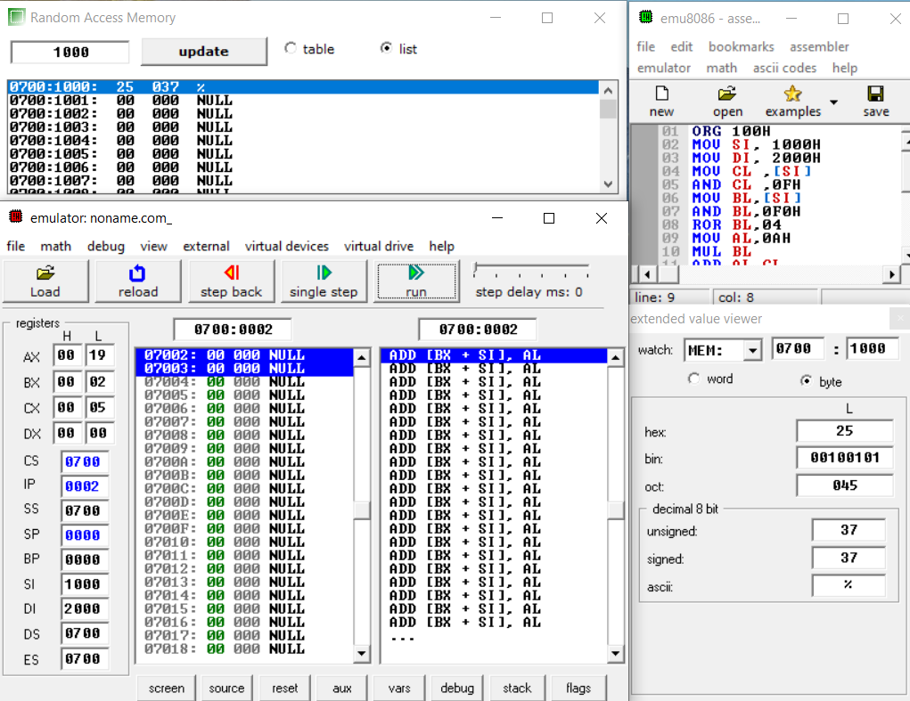

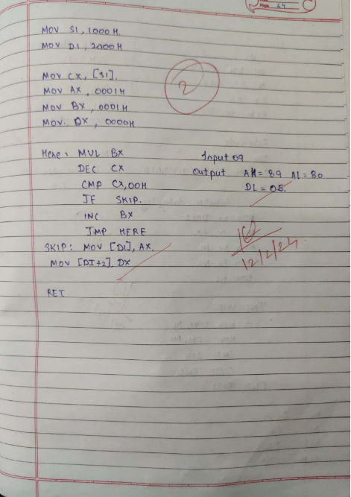

B) BCD to HEX

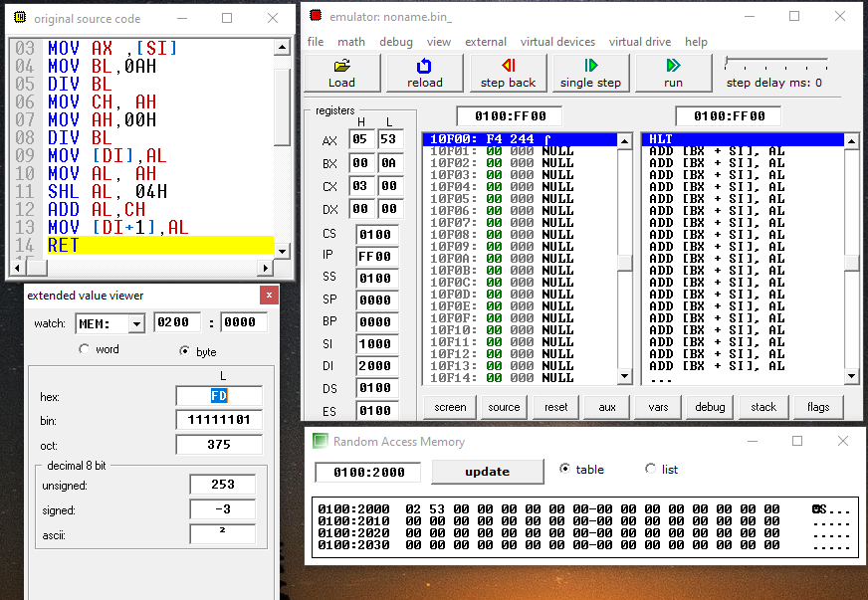

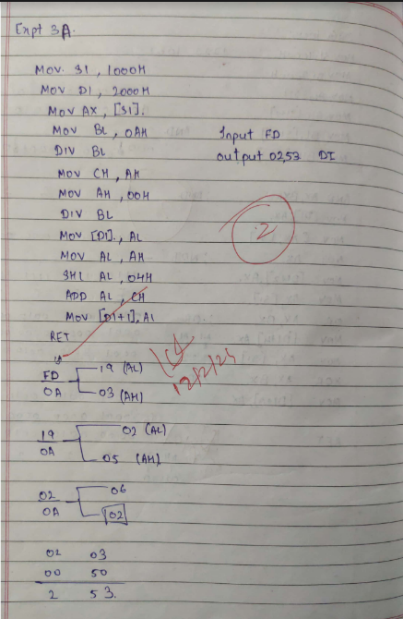

Conclusion: Here With by applying the Above logic we have successfully Learned how to convert a BCD number to Hex and Vice-versa with the help of 8080 Microprocessor and ALP